

Cake IT

Project Report

Name | Course Title | Date

# Abstract:

Home delivery via phone call is popular. The process seems easy to use but at times there is miscommunication sometimes. The main drawback of placing order via phone call is that there is no visual menu shown, the employees have to repeat a lot of things again and again to the customers. It’s a time consuming process which at times irritates customers. It would be much more comfortable for the customers to have an online ordering system. It would be hassle free for users as they can select the food item they want and make payment for it. Cake it Provides this convenient solution to the customers.

# Introduction:

Home delivery via phone call is popular. The process seems easy to use but at times there is miscommunication sometimes. The main drawback of placing order via phone call is that there is no visual menu shown, the employees have to repeat a lot of things again and again to the customers. It’s a time consuming process which at times irritates customers. It would be much more comfortable for the customers to have an online ordering system. It would be hassle free for users as they can select the food item they want and make payment for it. Cake it Provides this convenient solution to the customers.

Also it will reduce the purchasing time for customers. Let us look at another benefit of using this system. Suppose I go to a fast food point and make order. Even after ordering fast food from their outlet, I have to wait at least 15 minutes for my order to be ready. Wouldn’t it be much more convenient if I ordered my fast food before using an online system and then it will tell me the time by which I have to pick my order from their counter!! It would be great for me as I don’t need to wait for my order. I need to reach there only when my order is ready. In a nutshell, we can say that improved and efficient services are provided to the customers by the inclusion of internet in your business. As a business point of view it gives you an edge over your competitors.

# Functional and non-Functional Requirements

## Functional Requirements:

### Registration:

Application provides a link for the Users/Client Registration.

### Log in:

Administrator and Client can log in by entering user name and password and manage their work on website.

### Save information:

Client enter all its necessary information by filling personal info form and system save that information.

### Change requirements:

Customer can change any of their information any time.

### Food Menu:

Admin can insert, update and delete the food items from the menu list

### Show Food Menu:

There is a list of all types of food the company is dealing with the available themes.

## Non-Functional Requirements:

* The interface should use terms and concepts, which are drawn from the experience of the people who will make most of the systems.
* The system must provide easy and fast access without consuming much cost.
* User should never be surprised by the behavior of the system and it’s easy to retrieve and store data.
* Application will be able to work on any sort of operating system which has a browsers and internet connection.
* Secure and reliable system.
* Application will be able to work with a sufficient speed of internet connection

## 

# Usage Scenarios:

## Register:

|  |  |
| --- | --- |
| **Use case title** | Register |
| **Use case id** | UC.1 |
| **Actions** | Register client |
| **Descriptions** | A user of the System creates an account and view all stuff on  website. |
| **Alternative Paths** | |
| **Title** | **Description** |
| Cancel Registration | 1. The user selects the cancel option. 2. The system returns the user to the home page without the user being logged in and any information entered has been erased. |
| Invalid Information Entered | 1. User clicks submit after entering information system asked for. 2. System displays information with appropriate message to correct invalid information. 3. User re-enters information. |
| **Pre- conditions** | None |
| **Post- conditions** | |
| **Title** | **Description** |
| Success | The user entered successful information and is returned to the home page as a Logged In User |
| Failure | User is unable to log in for one or more reasons and is returned to the home page as a Guest. |
| **Exception** | 1. If client cannot access registration webpage, than client can wait for the webpage to be available. 2. If registration form is not yet submitted due to errors in registration form or internet connection than    1. reload the registration webpage, or    2. check inputs in the registration form |

## Change Requirements:

|  |  |
| --- | --- |
| **Use case title** | Change Requirements |
| **Use case id** | UC .2 |
| **Actions** | Change client requirements |
| **Descriptions** | Client can change its requirements even after placing order |
| **Alternative Paths** | |
| **Title** | **Description** |
| Cancel Changes | 1. The user selects the cancel option. 2. The system restore previous requirements. |
| **Pre- conditions** | Some requirements are already entered by client. |
| **Post- conditions** | |
| **Title** | **Description** |
| Success | The user change requirements successfully. |
| Failure | Some error occurred and system restore previous requirements |
| **Exceptions** | 1. If changes are not yet saved due to busy server or internet connection problem than    1. reload the webpage or   B. wait for a while until server is available. |

## Provide Feedback:

|  |  |
| --- | --- |
| **Use case title** | Provide feedback |

|  |  |
| --- | --- |
| **Use case id** | UC .3 |
| **Actions** | Client provide feedback |
| **Descriptions** | Client provide feedback of its experience. |
| **Alternative Paths** | None |
| **Pre- conditions** | None |
| **Post- conditions** | |
| **Title** | **Description** |
| Success | The user can successfully enter stars and comment in feedback |
| Failure | Some error occurred and user cannot enter feedback |
| **Exceptions** | 1. If feedback is not yet submitted due to busy server or internet connection problem than    1. reload the webpage or   B. wait for a while until server is available. |

|  |  |
| --- | --- |
| **Use case title** | Logged In |
| **Use case id** | UC .4 |
| **Actions** | User get access to system. |
| **Descriptions** | User logs in to the system through its username and password. |
| **Alternative Paths** | |
| **Title** | **Description** |
| User Fails  Authentication | If the User entered an invalid username and/or password, the following occurs:   1. The system describes the reasons why the User failed authentication. 2. The system presents the User with suggestions for necessary changes to allow the User to pass authentication. 3. The system prompts the User to re-enter the valid information. |
| **Pre- conditions** | None |
| **Post- conditions** | |
| **Title** | **Description** |
| Success | The User is authenticated and the system displays a home page based on the user type. |
| Failure | User is unable to log in for one or more reasons. |
| **Exceptions** | If user cannot have logged in due to internet connection problem or invalid username and/or password than   1. Reload the webpage or 2. Reenter username and/or password |

**Logged In**

|  |  |
| --- | --- |
| **Use case title** | Save client info |
| **Use case id** | UC .5 |
| **Actions** | Save client details. |
| **Descriptions** | System save all necessary details of client. |
| **Alternative Paths** | |
| **Title** | **Description** |
| Invalid Information Entered | 1. The system displays an “Invalid Information” error after the user submits the information and asks the user to re- enter the information. 2. User re-enters information and clicks submit. 3. System save all information |
| Cancel submission | The system returns the user to the home page without the information being saved and any information entered has been erased. |
| **Pre- conditions** | None |
| **Post- conditions** | |
| **Title** | **Description** |
| Success | Client information is saved into the database and is now search able |
| Failure | Information is not saved for one or more reasons. |
| **Exceptions** | 1. If client cannot access webpage, then client can wait for the webpage to be available. 2. If information is not yet submitted due to errors in personal information form or internet connection than    1. reload the webpage, or    2. check inputs in the personal information form |

## Save Client inf

|  |  |
| --- | --- |
| **Use case title** | Display Food Menu |
| **Use case id** | UC .6 |
| **Actions** | It display food menu. |
| **Descriptions** | System display all available food items to client. |
| **Alternative Paths** | None |
| **Pre- conditions** | Client must be registered with all required information. |
| **Post- conditions** | |
| **Title** | **Description** |
| Success | Client is registered and system show all available food items to client. |
| Failure | Food Menu are not displayed due to one or more reasons... |
| **Exceptions** | 1. If client cannot access food menu, than client can wait for the webpage to be available. 2. If client is not registered or error in internet connection than    1. reload the webpage, or    2. get registered first |

**Display Food Menu:**

|  |  |
| --- | --- |
| **Use case title** | Record Order details |
| **Use case id** | UC .7 |
| **Actions** | Record all necessary details of order. |
| **Descriptions** | System record all necessary details of order in order to deliver  the order to Client. |
| **Alternative Paths** | |
| Invalid Information Entered | 1. The system displays an “Invalid Information” error after the user submits the information and asks the user to re-enter the information. 2. User re-enters information and clicks submit. |
| Cancel submission | User cancel order by pressing cancel button... |
| **Pre- conditions** | None |
| **Post- conditions** | |
| **Title** | **Description** |
| Success | Order is successfully submitted with all necessary details. |
| Failure | Order is not submitted due to one or more reasons... |
| **Exceptions** | 1. If client cannot access webpage, then client can wait for the webpage to be available. 2. If information is not yet submitted due to errors in order details or internet connection than    1. reload the webpage, or    2. check inputs in the placing order form |

## Record Order Details:

|  |  |
| --- | --- |
| **Use case title** | Ask Delivery or Take away details |
| **Use case id** | UC .8 |
| **Actions** | Ask details of required order. |
| **Descriptions** | System ask all details of required from client. |
| **Alternative Paths** | |
| Invalid Information Entered | 1. The system displays an “Invalid Information” error after the user submits the information and asks the user to re-enter the information. 2. User re-enters information and clicks submit. |
| Cancel submission | User cancel submission by pressing cancel button |
| **Pre- conditions** | None |
| **Post- conditions** | |
| **Title** | **Description** |
| Success | Details are successfully submitted. |
| Failure | Details are not submitted due to one or more reasons... |
| **Exceptions** | 1. If client cannot access webpage, then client can wait for the webpage to be available. 2. If details are not yet submitted due to incomplete details or internet connection than    1. reload the webpage, or    2. check inputs in the Property details form |

**Ask Delivery/Take Away details:**

# Sequence Diagram for the Cakeit Food Application:

## 

# Adopted Methodology

The Methodology adopted for the development of this web application is the agile development methodology.

Agile SDLC model is a combination of iterative and incremental process models with focus on process adaptability and customer satisfaction by rapid delivery of working software product. Agile Methods break the product into small incremental builds. These builds are provided in iterations.

The Steps that are followed by the Agile SDLC are stated as follows:

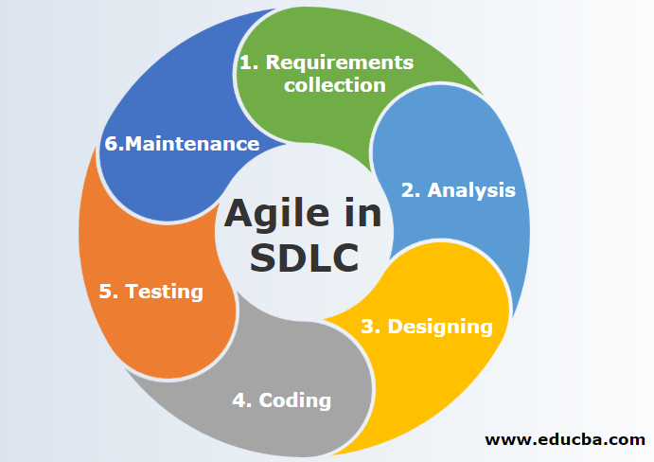

# Tools and Technology Requirements:

Hardware Requirements:

Processor

Intel ® Core™ i3-2370 CPU @2.40GHz

Installed Memory (RAM)

4.00 GB or above

Software Requirements:

Visual Studio 2019

Windows 10

# Working of the Cake it Application:

Main Page:

## 

The main page of the cake it Application is based on the food menu available here the user can select what he/she wants to eat from the menu and easily can add that into the cart.

Moreover, if you are a new user you can login sign up on this page or if you are a previous user you can simply login to the cake it Application.

There are also buttons for the Item available, Home and Contact us on the main menu bar. Which can also be used based on the need of the user.

Contact Us Page:

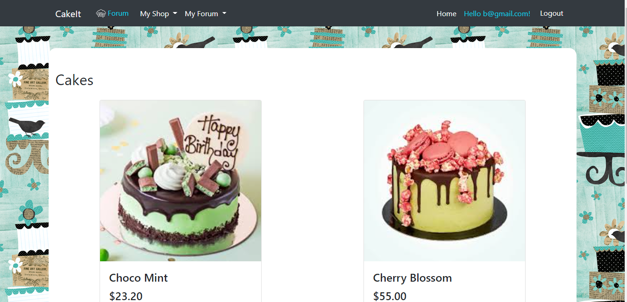

On the contact us page of the application the detailed address of the Cake it application is given so that the user is able to contact directly if needed.

Sign Up Page:

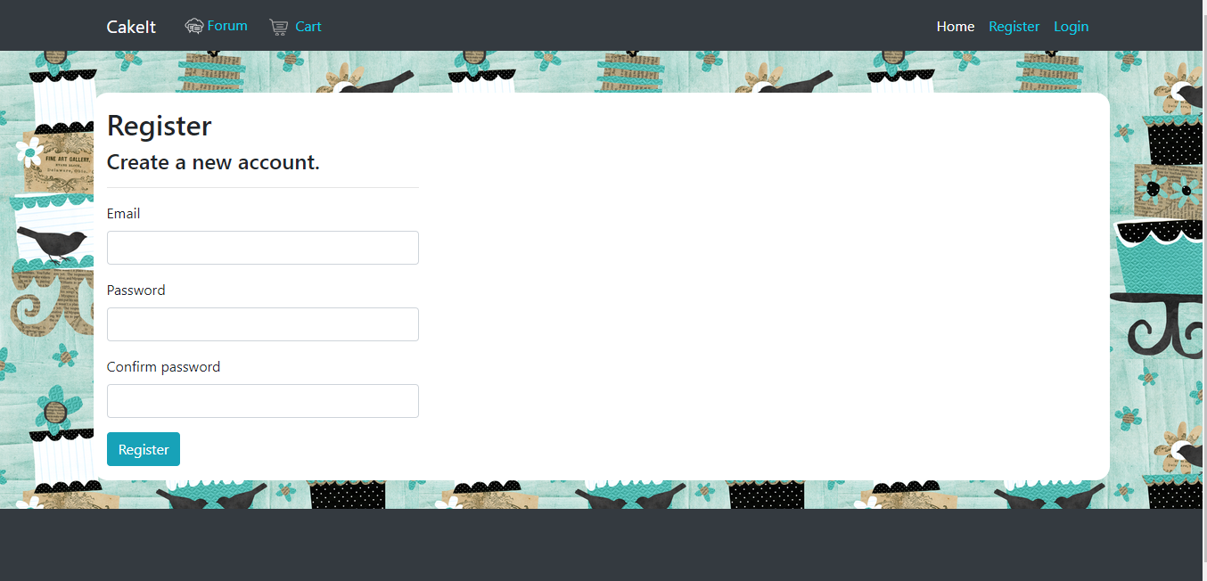

Here in this page the user can easily register with the Cake it Application by entering his name and password in the given registration form of the application.

Login Page:

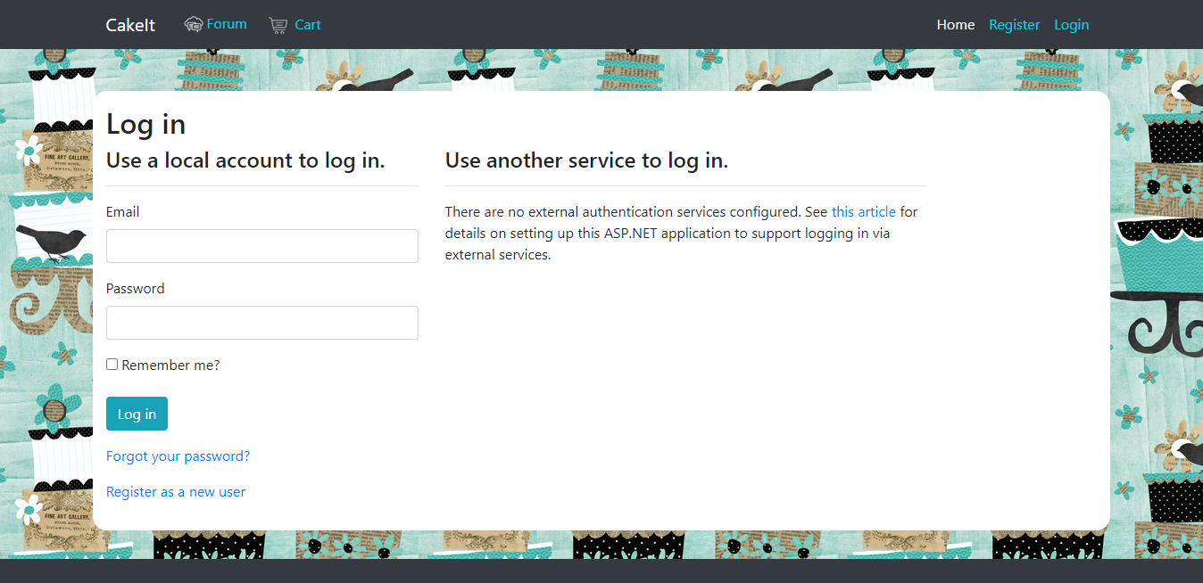

Here at this page the user can easily enter his/her credentials and login into the Cake it Application.

**Reference:**

cprime. (2021). *WHAT IS AGILE?* Retrieved from https://www.cprime.com: https://www.cprime.com/resources/what-is-agile-what-is-scrum/

cprime. (2021). *WHAT IS AGILE?* Retrieved from https://www.cprime.com: https://www.cprime.com/resources/what-is-agile-what-is-scrum/#:~:text=Agile%20software%20development%20refers%20to%20a%20group%20of%20software%20development,%2Dorganizing%20cross%2Dfunctional%20teams.

economictimes. (2021). *Definition of 'Waterfall Model'.* Retrieved from https://economictimes.indiatimes.com: https://economictimes.indiatimes.com/definition/waterfall-model

javatpoint. (2021). *Iterative Model.* Retrieved from https://www.javatpoint.com: https://www.javatpoint.com/software-engineering-iterative-model

theguardian. (2021). *Lumosity fined millions for making false claims about brain health benefits*. Retrieved from https://www.theguardian.com: https://www.theguardian.com/technology/2016/jan/06/lumosity-fined-false-claims-brain-training-online-games-mental-health

tutorialspoint. (2021). *SDLC - Agile Model*. Retrieved from https://www.tutorialspoint.com: https://www.tutorialspoint.com/sdlc/sdlc_agile_model.htm

w3schools. (2021, October 07). *SDLC RAD Model.* Retrieved from https://www.w3schools.in: https://www.w3schools.in/sdlc-tutorial/rad-model/

.